

School of Computer Science Engineering & Information Science
A Report on
Mini-Project
“PLACEMENT MANAGEMENT”
Course Title: Web Technologies
Course Code: CSE2258
Date of Submission: 22/11/2025

Submitted By:
Name | Roll Number
Koushik .M | 20241IST0106
Puneeth Reddy | 20241IST0107
Daanish Shariff | 20241IST0108
Vyshnavi | 20241IST0110
Anil Mallapa | 20241IST0111

Index
- Abstract
- Introduction
- Software and Hardware Requirements
- Modules/Functionalities
- Results with Screenshots
- Conclusion

01.Abstract :
Placement management plays a vital role in helping students make a smooth transition from academic learning to professional employment. It involves organizing, coordinating, and managing various activities such as training, career counseling, resume building, and campus recruitment drives. The system connects students with potential employers by understanding industry requirements and preparing students with the necessary skills. Effective placement management enhances employability, improves student confidence, and ensures that companies find qualified and job-ready candidates. Overall, it serves as an essential link between educational institutions and the corporate world, contributing to successful career development.

02.Introduction :
Placement management is an important process in educational institutions that helps students move from academic life to professional careers. It involves planning, organizing, and guiding students to secure suitable job opportunities. The placement department acts as a bridging students and companies by understanding industry needs and preparing students accordingly.
This process includes activities like skill development, resume preparation, communication training, mock interviews, and career counseling. Placement management also arranges campus recruitment drives where companies visit the institution to select qualified candidates. By coordinating with various organizations, the placement team ensures students receive exposure to real-world job requirements and gain confidence.
Overall, placement management plays a crucial role in shaping students’ futures by helping them build their careers, improving their employability, and connecting them with the right professional opportunities.

03.Software and Hardware Requirements:
Hardware Requirements
- Processor: Intel i3 or above
- RAM: Minimum 4 GB (8 GB recommended for smoother performance)
- Storage: 250 GB HDD or 120 GB SSD (SSD recommended)
- Monitor: 15-inch or above
- Keyboard & Mouse
- Printer/Scanner (for resumes, documents, reports)
- Network Devices: Router, Ethernet cables, Wi-Fi access
- Server (optional):
  - Intel i5/i7 processor
  - 8–16 GB RAM
  - 500 GB–1 TB storage
Software Requirements
System Software
- Windows 10/11 or Linux OS
- Server OS: Windows Server or Linux (if hosting on-premise)
Application Software
- Web Browser (Chrome, Firefox, Edge)
- Database Software (MySQL, SQL Server, Oracle, or PostgreSQL)
- Web Server (Apache, Tomcat, or IIS)
- Programming Platforms (depending on project):
  - Java / Python / PHP / .NET
- Development Tools:
  - VS Code / Eclipse / NetBeans / IntelliJ
- MS Office or Google Workspace
- Antivirus Software

04.Modules:
1. Student Management Module
- Student registration
- Uploading personal, academic details
- Resume upload
- Tracking training and placement status
2. Company Management Module
- Company registration
- Job profile details
- Requirements and eligibility criteria
- Scheduling recruitment drives
3. Placement Drive Management
- Creating & managing drive schedules
- Sending notifications to eligible students
- Attendance tracking during drives
- Round-wise selection updates (Aptitude, GD, HR, etc.)
4. Training & Skill Development Module
- Soft skills training
- Technical training sessions
- Mock interviews
- Resume building workshops
5. Eligibility Checking & Shortlisting
- Automatic filtering based on CGPA, skills, or criteria
- Generating list of eligible students
- Sending email/SMS alerts
6. Application & Selection Tracking
- Students apply to job openings
- Tracking application status
- Recording selected/rejected candidates
- Offer letter updates
7. Admin Management Module
- Manage users (students, staff, recruiters)
- Control system permissions
- Update system data and settings
8. Reports & Analytics Module
- Placement reports by department/year
- Company-wise selection statistics
- Student performance reports
- Export to PDF/Excel
9. Communication & Notification Module
- Email/SMS alerts
- Announcements for drives, training, or results
- Notifications inside the portal
10. Document Management
- Storing resumes
- Offer letters
- ID cards, certificates

05.Result:
The Placement Management System successfully streamlines the entire campus recruitment process by providing a centralized platform for students, placement officers, and companies. It automates tasks such as student registration, eligibility checking, company management, scheduling placement drives, and tracking selections. As a result, the system saves time, reduces manual errors, and improves communication between all stakeholders. Students can easily access job updates, apply for openings, and monitor their progress, while placement officers can efficiently manage data and generate accurate reports. Overall, the system improves transparency, increases placement efficiency, and enhances the overall experience of the placement process.

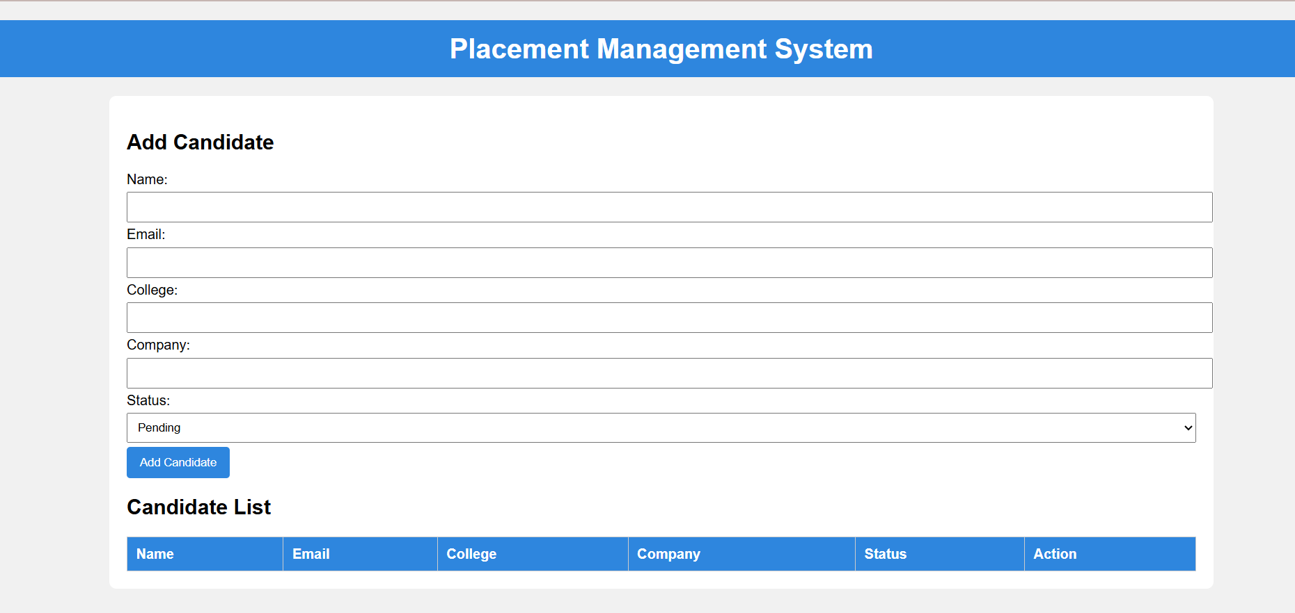
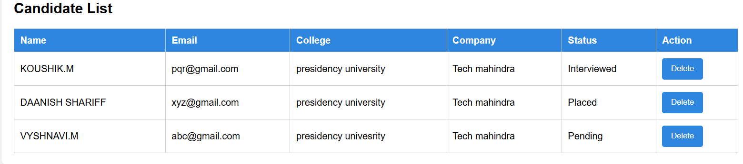

06.Conclusion:
Placement management plays a crucial role in bridging the gap between academic learning and professional careers. By organizing training programs, coordinating with companies, and managing placement drives, it ensures that students are well-prepared and confident for job opportunities. The system improves efficiency by automating tasks such as student registration, eligibility checking, communication, and result tracking. It also enhances transparency and reduces manual errors in the recruitment process. Overall, placement management helps institutions achieve higher placement rates, supports students in building successful careers, and strengthens relationships between educational institutions and industries.

